Eurobodalla Dressage Association

proudly presents the

2024 Eurobodalla Club Dressage Championships

Moruya Showgrounds

Sunday 24TH November 2024

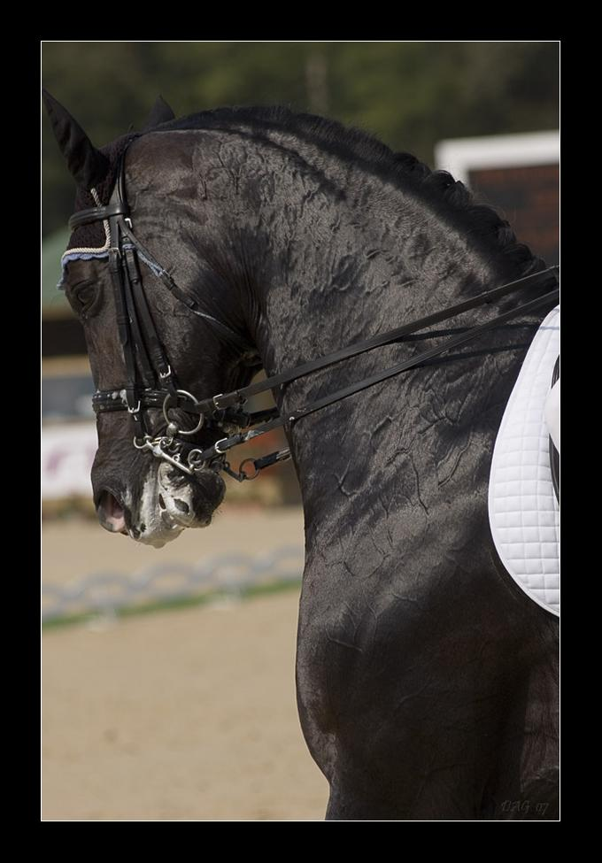

Conditions of Entry for all Competitors

The Eurobodalla Club Dressage Championships will be held under EA guidelines and will be a Club Members only event with CLOSED RESTRICTED classes.

Eligibility Criteria:
All competitors must have been a financial member of the Eurobodalla Dressage Association prior to 8th September 2024 to be eligible for a champion rug. If you have become a member after 8th September 2024, you can compete and be awarded ribbons but you won't be eligible for a champion rug. .Junior and Pony categories will also be offered under the same criteria. (Juniors must be under 17 as at 1/1/2024).

- Club Championship Rugs will be awarded at all open levels including Preparatory, Preliminary, Novice, Elementary and Medium. Competitors must enter both tests offered at chosen level to be eligible for Champion at that level and the highest aggregate % will be the winner.
  - N.B. The Preparatory level is an open event only (Ponies and Juniors may enter but scores do not count towards the Pony and Junior Champion). Only open to those horse/rider combinations who have not competed in Preliminary or above
- Champion Pony - Rug for Best 2% from any level above Preparatory (e.g. Preliminary and Novice, Novice and Elementary etc.)
- Junior Champion – Prize for Best 2% from any level above Preparatory
- King Brian Perpetual Trophy–Annual encouragement award for an EDA member

All riders please present at the presentations in your riding attire.

- Ribbons will be awarded 1st to 3rd
- Being a Championship event – no callers allowed
- All competitors must have a gear check before or directly after each test they have entered. Failure to do so will entail elimination
- Bridle Numbers are compulsory.
- Horses that are not entered on the draw cannot be at the grounds
- Competition is open to horses, galloways, ponies and stallions.
- Stallions must have their identification discs clearly displayed at all times
- Horses may compete in two consecutive levels (e.g. Prelim/Novice) but not more than two tests per horse.
- One rider may only ride a maximum of two horses on the day
- EA approved helmet (that has been tagged) and correct riding boots must be worn.
- Protests must be made within ½ hour of the posting of final scores to the scoreboard. A fee of $30 (which will be refunded if protest upheld) must accompany all protests. All protests must be in writing and given to the chief steward. The committee’s decision is final.

Risk Warning and Disclaimer

- Horse riding is a dangerous activity and can result in serious injury (including death) and loss
- All persons who ride, or tend horses on these grounds do so entirely at their own risk
- Neither Equestrian Australia, Eurobodalla Dressage Association , nor the Committee or any member thereof, accepts any liability for any personal injury (including death) suffered by any person from or relating to any incident involving a horse whether or not caused or contributed to by the negligent act, error or omission of Eurobodalla Dressage Association, the committee or a member

Club Championship Classes
EDA Members (prior to 8thSeptember 2024) only eligible for Championship rugs.
EA Prep 2– (Open to horse/Rider combination who have not placed 1st, 2nd or 3rd
in a Preliminary test or above.)
EA Prep 3- (Open to horse/Rider combination who have not placed 1st, 2nd or 3rd
in a Preliminary test or above.)
Preliminary 1.2 (Closed Restricted, Open, Junior, Pony)
Preliminary 1.3 (Closed Restricted, Open, Junior, Pony)
Novice 2.2 (Closed Restricted, Open, Junior, Pony)
Novice 2.3 (Closed Restricted, Open, Junior, Pony)
Elementary 3.2 (Closed Restricted, Open, Junior, Pony)
Elementary 3.3 (Closed Restricted, Open, Junior, Pony)
Medium 4.2 (Closed Restricted, Open,, Pony)
Medium 4.3(Closed Restricted, Open, Pony)
Advanced 5.2 (Closed Restricted, Open, Pony)
Advanced 5.3 (Closed Restricted, Open, Pony)

PLEASE NOTE:
- Gear check prior to (or immediately after) EACH test (failure to do so will result in elimination)
- Being our Club Championship – no callers are allowed
All Entries via Global: http://www.globalentriesonline.com.au/
Phone Enquiries:

Event Co-ordinator: Irene Adams Mobile No. 0481 193 002

Draw: Sue Berry 0448 718666

Club Championship Rugs and Ribbons (from 1st to 3rd) PLUS heaps of prizes will be awarded at the end of the day. Please present in riding attire to look great for the photos!

